
INTERIM GUIDANCE
Rehabilitation Management Data
GIS Standards
***NEW 2022 Fire Season – All Wildfire Rehabilitation data, mapping, and supporting documents MUST be completed from and stored in the below directory for the 2022 fire season and into the future seasons. No rehabilitation-related files will be stored on the BCWS Geomatics directory any longer. Please see the “Step 1 - Data Migration” section on page 10 for further details. ***
\\spatialfiles.bcgov\work\!Shared_Access\Provincial_Wildfire_Rehab\FireSeasonWork\2022

Contents
Scope 3
Purpose 3
Requirements – Restricted Data Access 4
KEY CONTACTS AND INFORMATION SOURCES 4
Organization 5
GDB Templates 5
Rehab Layer – Ten Themes 5
Overview 6
Six Key Attributes 6
Ten Themes 7
1 For Editing [Turn off when making maps] 7
2 OPS Point [PTType] 7
3 Rehab Point TREATMENT [RPtType] 8
4 Rehab Line Treatment [RLType] 8
7 OPS Feature Type [FLType] 9
8 Rehab Poly Treatment [RPType] 9
9 Status - Move below Top Base Layer 9
[Status] change FLOW 10
10 Priority Value - Move below Top Base Layer (and below Status) 11
Step 1 - Data Migration from the Incident to Rehab 11
Updating [Status] in Attributes in bulk 12
Step 1 12
Step 2 12
Points 13
Incident Points 13
Rehab Points 14
Lines 15
Incident Lines 15
Rehab Lines 15
Polygons 16
Incident Polygon 16
Rehab Polygon 16
QC Check List – after Data Migration 17
Step 2 - Process for Priority Values of rehab Points and lines 17
High Priority Points/Lines 17
Labels 18
Errors – DBMS 18
Data Sources 18
RAAD Priority Point/Line 18
Step 3 - Importing Field data 20
Receiving a KML – Import using Xtools Pro 20
No Schema 21
Bringing Data into the Rehab database 21
QC the KML Data 21
POINTS 22
LINES 22
Cleaning up the Data 23
Duplicate Lines 23
Guards that could be Modified Roads or just Heavely used Roads 25
Status 25
KML has Schema 26
Step 1 – Import Points and Lines with Attributes 26
Step 2 – Import Imagery 27
Photo Collection in Avenza 28
Process for PID Maps 28
Step 4 - GIS Products 28
MAPs 29
Map – QC 29
Map – Feature Order 30
Map – exporting Imagery 31
Map – Extent 31
Map Sets 32
Shrink PDFs using Adobe 32
Map Grid 32
Field Maps (Avenza) 33
Plotter Maps (Poster size) 33
High Priority Maps 33
Overview Maps (Poster size) 33
PID Maps (Private Parcels) 34
Exporting Data 35
Exporting to Shapefile 35
Exporting GDB 36
Naming Convention 37
MXD Naming Convention 37
PDF Map Naming Convention 37
Step 5 -Documention 37
Field Data Collection 37
Avenza 38
Importing Photos into Arcgis 38
Avenza User Guide 38
Avenza Maps Pro License 39
Field Data Submissions 39
Wildfire SDE 41
Imagery 41
1. BC GovermEnt Imagery 41
2. PlanET Labs Imagery (formally known as Black Bridge) 42
3. Ortholoader 42
Data and Records Management 42
Updates to Data Model 42
References, Resources and Links 43
APPENDIX 43
Broken Styles ? – Use the Tags on the right to try and make a new one. 43
Document History 44
Approvals 44

Scope

This document sets out the Spatial Data Standards for Wildfire Rehabilitation (rehab) mapping and data management. This includes the migration of GIS data from Incident (OPS) into the rehab database; identification of the status of rehab data as it moves through the rehab process; display of rehab data, potential known safety concerns, and high priority/critical locations (e.g. archaeological sites/potential areas and fish bearing streams). These standards provide a consistent process for field crews and GIS Specialists to follow and acts as a steppingstone for automated field data collection with direct uploading into a spatial database in the future.

Purpose
Consistent data management standards and practices are important for wildfire incident/rehab mapping. Consistency helps with incident/rehab staff turnover and creates a smooth transition for the incoming GIS Specialists. It allows rehab and GIS staff to work on multiple fires in different fire centres with consistent process, map symbology, and dataset structure. Consistency is also essential for summarizing rehab statistics by NRS Region, District, or Provincially. Spatial Data Standards for rehabilitation include:
- Standardized selection of incident data to be migrated into rehab database
- Standardized list of rehab treatments and definitions
- Standardized symbology
- Consistent rehab database standards
- Identification of high priority features that may require immediate attention.
- Rehab status of each feature (i.e. “Field Verification Required”, “Field Verified”, “Completed”, “Obligations Transferred”, and “PFR or Arch Survey Completed”)

Requirements – Restricted Data Access

Several layers required for Rehab mapping have restricted access. Prior to mapping, ensure you have permission to access these features in the BCGW database
- WHSE_ARCHAEOLOGY.RAAD_TFM_SITE
- WHSE_IMAGERY_AND_BASE_MAPS.DRP_OIL_GAS_FACILITIES_BC_SP
- WHSE_IMAGERY_AND_BASE_MAPS.DRP_OIL_GAS_PIPELINES_BC_SP

Contact Kyle Miller for assistance if you do not have access to either of these features.
Take special note that this data is restricted and sensitive in nature. Do not place data or maps with restricted data an external FTP site, unless the file is password protected and only if the contractors/licencee has the appropriate data sharing agreement in place. Do not release paper copies or data to unauthorized parties. Refer back to the FMP Catalogue for further details.

KEY CONTACTS AND INFORMATION SOURCES
Steve Richards – GIS Analyst
Office Phone: 250-985-2057 E-mail: Steve.Richards@gov.bc.ca

Kyle Miller – Wildfire Rehabilitation/Recovery Senior Project Specialist
Cell Phone: 250-267-8880
Office Phone: 250-302-5682 E-mail: KYLE.mILLER@gov.bc.ca

Provincial (PWCC) and Regional (RWCC) Wildfire Coordination Centre Contact Information

Contacts | 24hr phone# | Plans Phone Number | Plans Email Address | E-mail Alias
Provincial Wildfire Coordination Centre | 250 376.6777 | 250.312.3040 | HPR.PLANS@gov.bc.ca | HPRPLANS
Coastal RWCC | 250 951-4222 | 250 951-4274 | BCWS.COFCPlans@gov.bc.ca | COFCPLAN
Northwest RWCC | 250 847-6600 | 250 847-6633 | BCWS.NWFCPlans@gov.bc.ca | NWFCPLAN
Kamloops RWCC | 250 554-5500 | 250 554-5512 | BCWS.KFCPlans@gov.bc.ca | KFCPLANS
Southeast RWCC | 250 365-4040 | 250 365-4062 or  250 365-4064 | BCWS.SEFCPlans@gov.bc.ca | SEFCPLAN
Prince George RWCC | 250 690-2300 | 778 693-2877 | BCWS.PGFCPlans@gov.bc.ca | PGFCPLAN
Cariboo RWCC | 778 779-2030 | 778-799-2055 | CARPLANS@gov.bc.ca | CARPLANS

Organization

GDB Templates

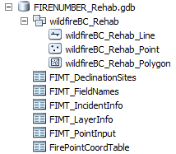
FIRENUMBER_Rehab.gdb
\\spatialfiles.bcgov\work\!Shared_Access\Provincial_Wildfire_Rehab\Resources\GDB

Rehab Layer – Ten Themes
Action:
Option A: Copy this MXD template into the Fire rehab folder and add fire Number to name (Ex: C41866_REHAB_Editing.mxd).
\\spatialfiles.bcgov\work\!Shared_Access\Provincial_Wildfire_Rehab\Resources\Map_Templates\REHAB_Editing.mxd
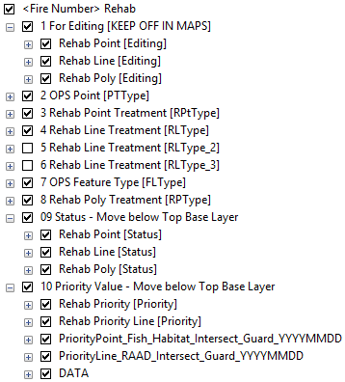
Option B: Bring these two features into your working MXD.
- FIRENUMBER_Rehab.lyr &
\\spatialfiles.bcgov\work\!Shared_Access\Provincial_Wildfire_Rehab\Resources\Layer_Files

- WHSE_ARCHAEOLOGY.RAAD_TFM_SITE
Note: The attributes tables are better set up in the MXD.

To fix all of the broken links at once.
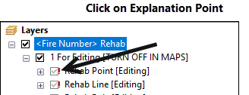
Click on the first ! (not the box but the actual !) Point it towards the wildfireBC_Rehab_Point in the local Rehab database. All of the others features should find its source automatically.

Rehab Styles
\\spatialfiles.bcgov\work\!Shared_Access\Provincial_Wildfire_Rehab\Resources\Symbology

If the GDB was copied into the Fire Project folder before April 2019, you will not be working with the latest GDB. If you are only making minor edits to an existing Rehab Project, you should not consider switching to the latest GDB. If the 2018 GDB was used, all of the rehab treatments and Status options may not be available and you may want to update the domains instead of moving the data into the latest GDB.

Overview

There are five major Sections in Rehab:
Step 1: Data Migration - Importing data from Incident into Rehab Database.
Step 2: Priority Points – Process for Priority Values of rehab Points and lines
Step 3: Importing Field Data - Managing 6 key attributes, in three rehab features (point, line and polygon) will display the data into 10 different themes (listed in the above section).
Step 4: GIS Products - Cartography and Table products
Step: 5: Documentation

There are two large differences between the way the incident and the Rehab databases function: the [Status] and the [Priority Values]. More detail will be provided in the Ten Themes section below.
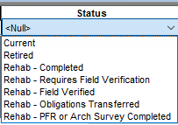
- The [Status] now has additional options. There are also associated [Attributes] that allow the GIS Specialist to track the changes in Status. From being moved from incident and through to completion.

- As mentioned previously, there are three types of rehab Priority points/lines.
- In the field, the Rehab Specialist can assign any rehab point/line as a critical point/line.
The Second two sets are to be assigned by the GIS Specialist
- Rehab Points and Lines that are within 50m of an Arch Site (RAAD). An additional 25m is added to account for data collection error.
- A new feature is created to point out where guards cross that cross potential fish bearing streams.

Note: Rehab Specialist can make a request to include, other sensitive features, such as High or Moderate Arch potential areas.

Six Key Attributes

There are Six Key Attributes that will move points, lines, and poly from different stages of rehab organized into the Ten themes displaying different attributes of the same feature. The six key Attributes:
- Label
- Rehab Type (RPtType, RLType or RPType)
- Incident Type (PTType, FLType or IPType)
- Status
- Priority Value
- Priority Label
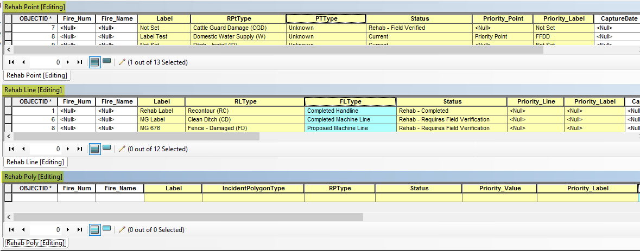

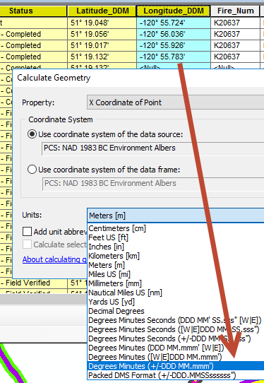
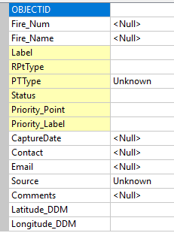
Other Attributes that require updating (same as in incident guide pg 62). See the list on the right. Name of fire and comments are optional. For legal reasons, attributes such as the [Comments] (populated with who provided the data) and the [Capture Date] can help is some legal or property/claims disputes. New set of comments attributes have been added to keep track of who/contractor and when the rehab data was provided to the GIS specialist and when there was a status change. This will be described later in this document, under the 9th Theme, 9 STATUS. When updating the Lat and Long follow the same process as the incident guide (see pic below).

Ten Themes

The six key attributes will drive the data in the following ten themes, displaying different attributes of the three rehab features (point, line and polygon).

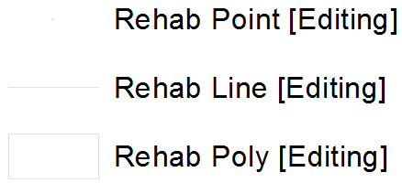
1 For Editing [Turn off when making maps]
This group should be turned off for map production but helpful when editing to only have these three selectable with the tables open and with Query: [Status] <> ‘Retired’. When you are editing the location or attribute using just these three layers (only have these three layers selectable) it will update the themes and allow GIS Specialists to see the symbolization on the fly. i.e confirmation the coding was accurate.

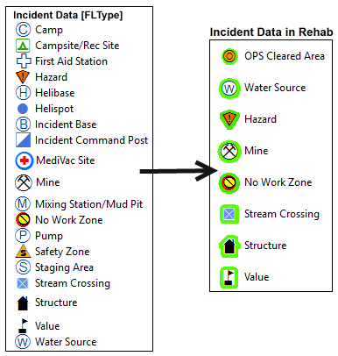
2 OPS Point [PTType]
This layer has Points that were migrated over from Incident; the label will be placed by the Rehab Treatment point even if ‘No Treatment’ has been assigned. The [Status] will start as ‘Rehab - Requires Field Verification’. Once a Rehab Specialist has visited this in the field the [Status] can be converted to ‘Rehab - Field Verified’ and a rehab treatment can be assigned. Once a rehab treatment [RPType] has been assigned it will no longer fall into this theme. Not all points well keep the original Symbology; many will be grouped into a Cleared Area Category.
Note: ALL Camp Site, mine, hazard, Structure, and no work zone stay as they are but with no halo. They should not be assigned any treatment type, not even a ‘No Treatment’.

3 Rehab Point TREATMENT [RPtType]
There are 49 options, some of these are safety points and one is just to display the division labels. Since the division sections are captured as a linear feature it’s difficult to keep track of the naming of the divisions without the use of a point.

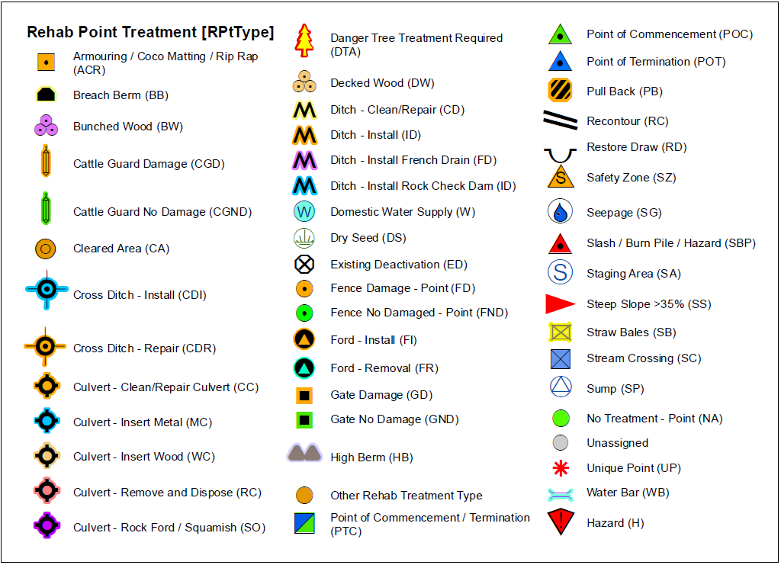

4 Rehab Line Treatment [RLType]
There are 18 options in the GDB RLType Domain, included are division breaks even though it is not a rehab type. Any new line is defaulted to ‘Unassigned’ or an existing line can be attributed as ‘Unassigned’ where treatment does not need to be displayed. In some cases, more than one rehab treatment can be assigned to the same line; there are two additional attributes that will allow for this [RLType_2] and [RLType_3].

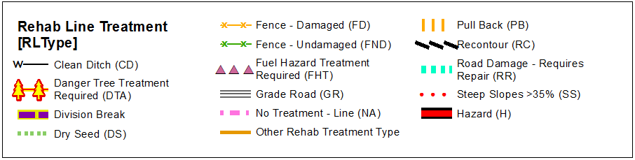

7 OPS Feature Type [FLType]
This displays the action that occurred on the ground during the incident, and a few safety features and other linear features of interest that were imported in from Incident. Guards and other incident lines that were not previously collected can be added during Rehab. More detail will be provided in the Data Migration Section.

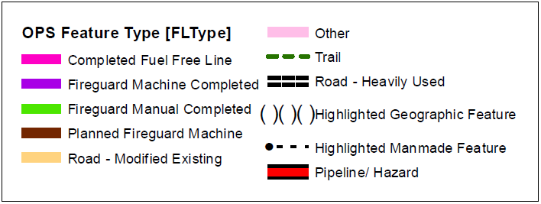

8 Rehab Poly Treatment [RPType]
These 11 features are rarely used. In but the most extreme cases, a polygon feature can be avoided by simply using a Rehab Point or Rehab Line Treatment feature. For instance, typically a Cleared Area (CA) will cover a larger area (100X100m in some cases) and a point feature would be used instead of an actual polygon to cover this area. Unless there is a very specific reason to do so, use a point or line and discuss with the Rehab Specialist, if needed.

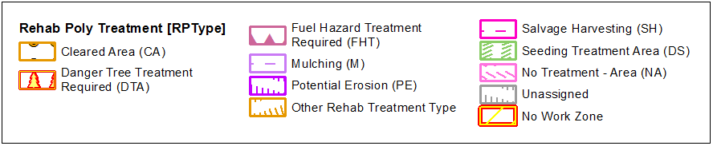

9 Status - Move below Top Base Layer
This feature should be moved below the Top Base layer but should remain above the Priority Value. This feature has other [Status] options, one to account for data that required field checking once it has been migrated from Incident and a second one to show that the rehab has been completed. If any additional status options are required, please see Data Model Section.

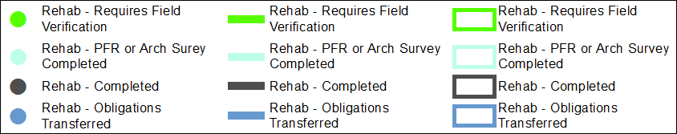

[Status] change FLOW
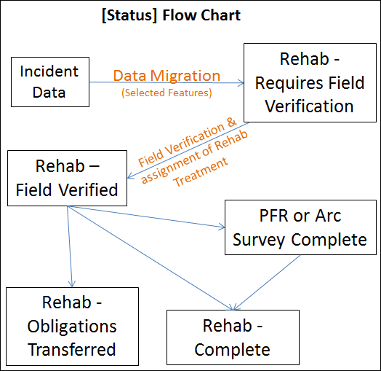
- All features that are migrated into the rehab database will be given a [Status] of ‘Rehab - Requires Field Verification’. A green halo is added around the feature and indicates that field verification is required.
- Once a Rehab Specialist has verified a feature in the field, the [Status] is changed to ‘Rehab - Field Verified’ and the green halo is removed. The proposed Rehab Treatment (or “No Treatment”) should be assigned at the same time, and replaces the incident feature type in the display.
- Potential safety issues identified in the incident data (eg. No Work Zone, Hazard, Mine, etc.), should remain on the rehab map. The green halo is removed once field verified.
- NEW [Status] of ‘PFR or Arch Survey Complete’ might be required after the feature has been field verified and may occur before any rehab treatments can occur. A bright blue/green halo is added around the feature and indicates that it has been surveyed.
- Once the rehab has been completed the point is given a [Status] of ‘Rehab – Completed’, and a dark grey halo is added around the feature.
- If rehab is identified and is transferred to a third party, the feature is given a [Status] of ‘Rehab – Obligations Transferred’. Some examples include claims paid out rather than rehab work being actioned by BCWS, and a third party agrees to assume responsibility for the rehabilitation - usually because the party wants to use the access created by fire control for their own purposes (eg. BC Hydro for power infrastructure repairs, Forest Licencees for salvage harvesting).
Atlantic Blue halo is added around the feature and indicates that obligations have been transferred.

Action for the Rehab Specialist: Obligations Transfers should be supported with written documentation that relieves the Crown of any further obligation. The rehab specialist should provide to the GIS Specialist with the legal name of the party taking on the rehab obligations and the effective date, so this information can be recorded in the GIS database. See below table for example.

Action for GIS Specialist: When using Obligations Transferred, and not provided with proper documentation ask Rehab Specialist for legal name of the party taking on the rehab obligations and the effective date, so this information can be recorded in the GIS database.

Action: When there is a change in [Status] the name and date (YYYYMMDD) of Rehab Specialist or contractor should be recorded when there is a change in status or additional data has been received. Additional attributes have been added to accommodate changes in [Status]. Five new attributes have been added:

- [Comments_Status_Rehab_Field_Verified]
- [Comments_Status_Rehab_Completed]
- [Comments_Status_Rehab_ObligationsTransferred]
- [Comments_Status_Rehab_PFR_ArcCompleted]
- NEW [Rehab_Contractor_Name_EMail_ContactInfo] (not in pic below) – Ask Rehab Specialist for this info
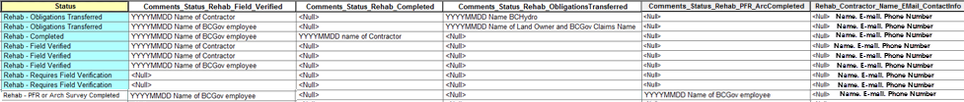

10 Priority Value - Move below Top Base Layer (and below Status)
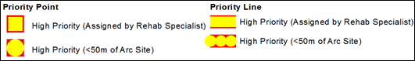
NEW: Fish bearing streams is no longer being used to create Priority Point due to data source issues.

As mentioned previously, there are three types of rehab Priority points/lines.
- In the field, the Rehab Specialist can assign any rehab point/line as a critical point/line.
- The second sets are to be assigned by the GIS Specialist. Rehab Points and Lines that are within 75m of an Arch Site (RAAD). This includes an additional 25m to account for data collection error.

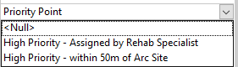
For the ease of automation domains have been used for both points and Lines. It’s likely a Rehab Line will have to be broken to only account for the length that falls within 75m of an Arch Site. Remember, if the line section is too small, it may not be seen in the maps. When dealing with a feature line, make sure it will stand out on the maps and exaggerate if needed.

Note: Rehab Specialist can make a request to include other sensitive features, such as High or Moderate Arch potential areas.

More detail and the process for the GIS Specialist can be found in Step 3: Process for Priority Values of rehab Points and Lines

Note: The process for Priority Values needs to be repeated when new Guards or Rehab data is added to database. You may receive data from a contractor and then supply the contractor with database or KML.

Step 1 - Data Migration from the Incident to Rehab
***NEW 2022 Fire Season – All Wildfire Rehabilitation data, mapping, and supporting documents MUST be completed from and stored in the below directory. No rehabilitation-related files will be stored on the BCWS Geomatics directory any longer***
\\spatialfiles.bcgov\work\!Shared_Access\Provincial_Wildfire_Rehab\FireSeasonWork\<FIRE YEAR>

***NEW – Incident data cannot be accessed from the BCWS Geomatics server any longer. All incident data is compiled nightly by fire season year and placed in the below directory for Ministry of Forests staff to use for data migration into the Wildfire Rehabilitation datasets. Access to the BCWS Geomatics directory is strictly prohibited for Wildfire Rehabilitation. Please contact BCWS Geospatial Services (BCWILDFIREGEO@gov.bc.ca) if you require assistance or have any questions.

\\spatialfiles.bcgov\work\!Shared_Access\Provincial_Wildfire_Rehab\FireSeasonWork\ProvincialRollUp

***NEW –Before migrating data, ensure you have a project folder set up using the template folder structure, found below. Make a copy of this folder and paste it into the appropriate Fire Center and Fire zone folder that the incident resides in. You can then copy over the template MXD and populate the supplied Wildfire Rehab GDB with the appropriate incident data. All mapping and export documents should be completed within your new incident folder.

\\spatialfiles.bcgov\work\!Shared_Access\Provincial_Wildfire_Rehab\FireSeasonWork\2022\!TEMPLATE

Data migration involves moving selected data from the incident dataset into the rehab dataset, and include points, lines, and polygons.

Not all incident features will be migrated over to rehab database, and only features with a [Status] set to ‘Current’ will be of interest. With exception to of Camps and Staging Area, even ‘Retired’ points will be migrated. Once data has been migrated it will be given a [Status] of Rehab- Requires Field Verification. Additional detail is provided below.

PFR stands for Preliminary Field Reconnaissance.

Updating [Status] in Attributes in bulk

During Data migration, it will be easier if you use the Attributes button found in the Editor Tool to change attributes in bulk while updating the [STATUS] by using the domain dropdowns. This is a very handy way to update multiple attributes in bulk.

Before making lots of changes it’s always best to back up the GDB.

Step 1
In an editing session, open the feature table and select all of the records that you want to update with the SAME attribute. In this case, update all of the records that you want [Status] to be ‘Rehab – Requires Field Verification’. Click on the Attributes button in the Editor Toolbar.
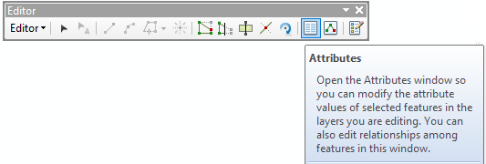

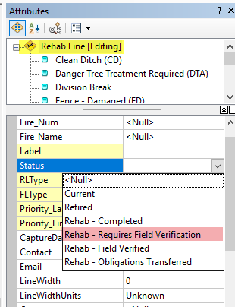

Step 2
In the Attributes window, click on the top line “Rehab Line [Editing].” This will update all records in the list below it.

It will give you access to the domain values as a dropdown.

In the dropdown on the Right and Select “Rehab – Requires Field Verification”.

Check table to make sure you like the attribute change.

Save edits and repeat process for Point and Poly.

Points

Incident Points

Not all incident points will be migrated into the rehab database. The list on the right shows the selected incident points that should be migrated into the rehab database. These selected incident points are only migrated if the [Status] is set to ‘Current’, with the exception of Camps and Staging Areas where ‘Retired’ points should also be migrated over as they may have been disturbed and require field verification. Once a point has been migrated over into the rehab database from the incident database the [Status] will be set to ‘Rehab - Requires Field Verification’. Not all points will keep the original Symbology; many will be grouped into a Cleared Area category to simplify things. A green halo will be added around the symbol to show that it requires field verification by a Rehab Specialist.

Note: An exception for Camps and Staging areas, even ‘Retired’ points will be imported because they could have existed causing disturbance on the ground then set to be ‘Retired’ because the location changed. These ‘retired’ areas could require rehab and require a field visit.

Actions:
- Start Editing Rehab Points
- In Incident Database select the PTType in the pic above and copy them into the Rehab Database. Include ‘Retired’ Points for Camps and Staging areas.
Selection Query: (PTType IN ( '3', '4', '7', '9', '10', '12' ,'13', '16', '17', '18', '20', '23', '25', '26', '29', '31', '32', '33', '34') AND Status = 'Current' ) OR ( Status = 'Retired' AND PTType IN('3','25'))
- Copy, clear the selection and then paste points into Rehab Database.
- Using the Attributes Button in the Editor Toolbar – in bulk, set [Status] to ‘Rehab - Requires Field Verification’. If needed, see previous page for instruction on how to do this.
- Check to make sure the [RPtType] is set to ‘Unassigned’.
- Open the table and check the Attributes.
All incident points visited in the field should have the [Status] changed to ‘Rehab – Field Verified’, the green halo will disappear, and each point will then fall into one of these three options:
- Assign a rehab treatment, which will then be displayed accordingly, or
- Assign ‘No Treatment’. “No Treatment” points should remain on the map so that it is clear that they were assessed in the field. i.e. do not ‘retire’ the point.
- Verify potential safety issues identified in the incident data (eg. No Work Zone, Hazard, Mine, etc.), as necessary. The symbology for potential safety issues should remain on the rehab map. The green halo is removed if area was field verified.
Note: Campsite/Rec Site, Hazard, Mine, No Work Zone and Structure will not likely be assigned a ‘Rehab Type’ and will remain as a PTType (No rehab action assigned) with the green halo removed since the [Status] was updated to be field verified.
Example:
The diagram below displays three incident points that were field verified and the [Status] was changed from ‘Requires Field Verification’ to ‘Rehab – Field Verified’. The Camp was given a rehab treatment of ‘No Treatment’. The MediVac site was field verified and assigned a rehab treatment of ‘No Treatment’ (NB: Symbology changes from  to a green dot with the green halo removed indicating that the site has been field assessed and no rehab action is required). The Cleared Area has been assigned a rehab treatment of ‘Recontour’ and also requires ‘Dry Seeding’. In this case, the OPS point was given a treatment of Recontour and then a Rehab point was added to apply a second rehab treatment of Dry Seed.
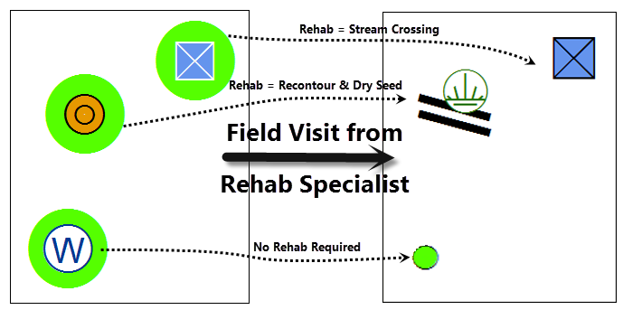

Rehab Points
This is a list of all possible rehab treatments. Depending on the specific situation on a particular fire and the rehabilitation to be undertaken, many of these potential treatments may not apply.
Actions:
- Once the rehab treatment has been assigned, set the [Status] to ‘Rehab - Field Verified’. If this was an incident point, the green halo will disappear.
- Populate the Attribute [Comment _Status_Rehab_Field_Verified] with Data (YYYYMMDD) and the name of the Rehab Specialist or Contractor.

Lines

Incident Lines
The list below shows which incident lines will be selected to be migrated into the rehab database. Only those with [Status] set to ‘Current’ will be migrated. Unlike the points, the lines will not keep their original symbology as they will be grouped into the new categories
Incident Line Type [FLType]
Completed Handline
Completed Fuel Free
Completed Line
Completed Machine Line
Containment/Control Line
Contingency Line
Proposed Machine Line
Fire Break Planned or Incomplete
Line Break Complete
Planned Fire Line
Planned Secondary Line
Highlighted Geographic Feature
Highlighted Manmade Feature
Road – Modified Existing
Pipeline / Hazard
Other
Trail
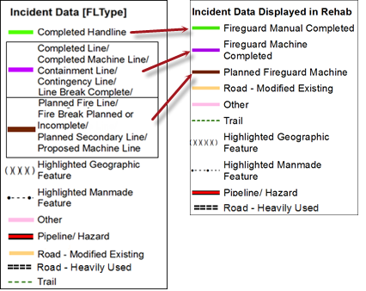

Actions:
- Start editing session for the Rehab Lines.
- In Incident Database select the [FLType] in the pic above and copy them into the Rehab Database.
Selection Query: Status = 'Current' AND FLType IN ('10','30','11','9','37','28','24','16','20','21','22','18','27','35','32','33’,’34')
- Copy, clear the selection then paste into the Rehab Line database.
- Using the Attributes Button in the Editor Toolbar – In bulk set [Status] to ‘Rehab - Requires Field Verification’.
- Check to make sure the [RLType] is set to ‘Unassigned’.

Rehab Lines
Rehab Line Treatment Options:

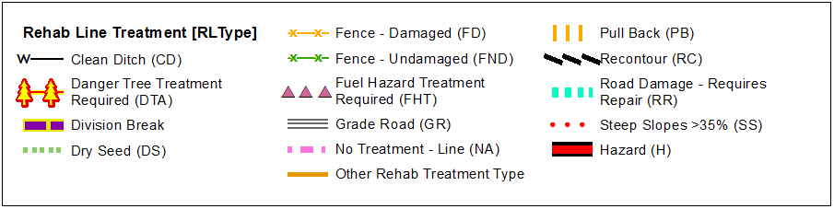
Not seen above is the ‘No Treatment’ and ‘Unassigned’ Rehab Types. All lines are defaulted to ‘Unassigned’ or an existing line can be attributed as ‘Unassigned’ where treatment does not need to be displayed. After the data is migrated from incident there may still be new Guards being added into the Rehab database and they will be defaulted to ‘Unassigned’. The [FLType] will need to be assigned and can be given a [Status] of ‘Field Verified’.
Note: If a line is added and no [FLType] or [RLType] is assigned it will not show up on the map.

There may be up to three rehab treatments available for each line. For example: Clean Ditch, Grade Road, and Dry Seed can all occupy the same line segment. There are three different attributes ([RLType], [RLType_2], [RLType_3]) for each Rehab Treatment Type.

Actions:
- Once the rehab treatment has been assigned set the [Status] to ‘Rehab - Field Verified’. The Green halo will disappear.
- Populate the Attribute [Comment_Status_Rehab_Field_Verified] with Data (YYYYMMDD) and the name of the Rehab Specialist.
Examples:
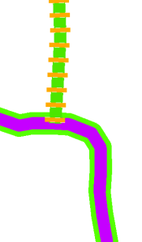
“Fireguard Manual” that was field verified (green halo removed) and assigned a proposed Rehab treatment of “Pull Back”, and
“Fireguard Machine” that has not been verified in the field (green halo remains).

“Fireguard Manual” that was assigned a Rehab treatment of “Pull Back” (green halo is removed), the work is completed, and the status is set as completed (grey halo added), and
“Fireguard Machine” that has not been verified in the field (green halo remains).

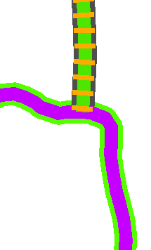

Polygons

Incident Polygon
Only one polygon feature is migrated from Incident database into the rehab database.

Incident Poly Type
No Work Zone

Actions:
- If Incident has a ‘No Work Zone’, copy, clear selection and paste into Rehab Poly.
- Set [Status] to ‘Rehab - Requires Field Verification’. This way when a rehab specialist knows it came from Incident and not a rehab specialist.
- Check to make sure the [RPType] is set to ‘Unassigned’.

Rehab Polygon
Rehab treatment options:

Actions:
- Once the rehab treatment has been assigned set the [Status] to ‘Rehab - Field Verified’. The Green halo will disappear.
- Populate the Attribute [Comment _Status_Rehab_Field_Verified] with Data (YYYYMMDD) and the name of the Rehab Specialist who provided/collected the data.

QC Check List – after Data Migration
- [Status] <> ‘Current’, replace with ‘Rehab – Requires Field Verification’
- Are there guards on roads? Set up a meeting with the Rehab specialist to see if these should be “Road – Modified Existing”, “Road – Heavily Used”, “Road”. Some can be confirmed that’s not Guard with Imagery but others will require field verification.
- Messy or duplicate lines? See cleaning up the data section below. In Rehab, line length matters.
- [RLType] ≠ <Null>, replace with ‘Unassigned’
- If [RLType] = ‘Roads Non-Status with Obligations (RNS)’ or ‘Roads Tenured with Obligations (RT)’ then [FLType] <> a guard. Ask the Rehab specialist if [FLType] should be “Road – Modified Existing”, “Road – Heavily Used” or “Road”.
- Linear lengths are important in Rehab. Check for messy or duplicate lines. For larger fires see the section on Cleaning Up the Data for ideas. Remember to recalculate the [Metres] once you have made edits.

Step 2 - Process for Priority Values of rehab Points and lines
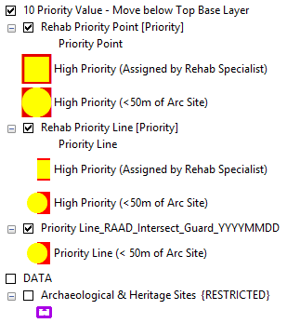
Note: The process for Priority Values needs to be repeated when new Guards or Rehab data is added to database.

Note: Fish Bearing Streams use to be part of this analysis but has been removed for now due to data source issues.

High Priority Points/Lines
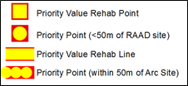
NEW: Domains have been added for this attribute
Specific points or lines may be identified as a high priority point or a high priority line for rehabilitation. High priority points/lines are areas where there is a high risk of unintended consequences if rehab work is not undertaken prior to the next high intensity rainfall event and/or spring freshet.
The GIS and Rehab Specialists should work together to identify potential high priority areas:

- Rehab points, lines, and/or polygons are identified by the Rehab Specialist in the field as a high priority (e.g. stream blockage, fireguard constructed on unstable soils or erodible soils on steep slopes, archaeological find, etc.). A unique identifier(s) for the map label should be determined by the Rehab Specialist, otherwise, one will be assigned by the GIS Specialist.

These points should be displayed as a table (Graphic Table Element) in the maps with coordinates (DDM).

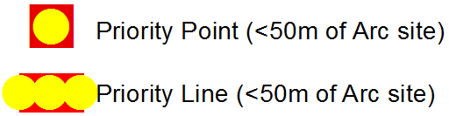
- Map based information identified by the GIS Specialist as potential high priority is limited to a point feature where a rehab point/line crosses an archaeological site or is within 50 meters of an archaeological site. This may also include rehab treatments within High and/or Moderate Archaeological Potential Polygons depending on the local circumstances/protocols.

These points identified by the GIS specialist will NOT be displayed in a table and not given a unique identifier unless requested by the Rehab Specialist.

Process for this can be found in a later section Process for Priority Values of Rehab Points and Lines

Labels
Each high priority point, line, and polygon in the rehab database (not the Fish bearing streams or within 50m of a RAAD Site) should be assigned a unique priority identifier (i.e. Priority_Label) by the Rehab Specialist.

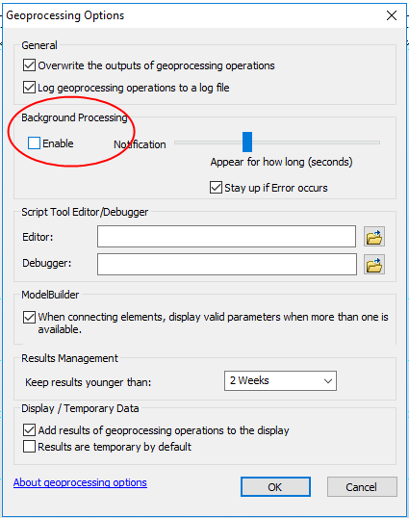
Errors – DBMS
When running a process using data on the BCGW and you are asked to log into the Database Connection, then receive this error.
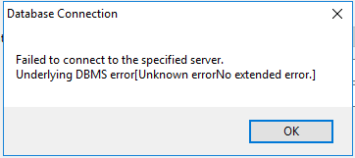

Go into Geoprocessing Options and Uncheck Background Processing.

Data Sources
Arch Sites
BCGW Catalogue
WHSE_ARCHAEOLOGY.RAAD_TFM_SITE
Query (updated): REGISTRATIONSTATUS IN ('Decision Pending', 'Federal Jurisdiction', 'Legacy', 'Recorded/Unprotected', 'Registered', 'Registry Candidate')

RAAD Priority Point/Line
Take special note that archaeological data is restricted and sensitive in nature. Do not place data or maps with archaeological data (Arch Potential or RAAD data/Archaeological Sites) on an external FTP site, unless the file is password protected and only if the contractors/licencee has the appropriate data sharing agreement in place. Do not release paper copies or data to unauthorized parties. Refer back to the FMP Catalogue for further details.

This process involves two steps, one for the point and the other for a line.
Rehab Point
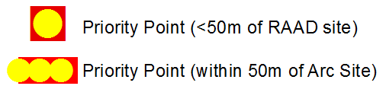
Goal: to determine which rehab points are priority points due to their proximity to Arch RAAD sites
- Start editing Rehab Point
- Select by location for any point within 75m of an RAAD Site (75 m was used instead of 50m to account for 25m of error with the Rehab Data point collection).
- IF the rehab point is not currently classified as a Priority Point (by a rehab specialist) then populate [Priority_Point] attribute with “Within 50m of RAAD site”.
Note: A priority point assigned by a Rehab Specialist will always take precedence.
- Give this critical point different symbology than the ones assigned as priority point assigned by the Rehab Specialist. The priority point assigned by the rehab specialist should have a label. Appropriate symbology in image above and in Rehab Priority Layer within layer file.
- Save edits and stop editing.
- When new Rehab points are added to the database remember to check for new priority points that should be added to this database. Send out updated datasets if required.

Rehab Line
Goal: To select out rehab lines within 75 of Arch Sites and update attribute to be a priority Line.

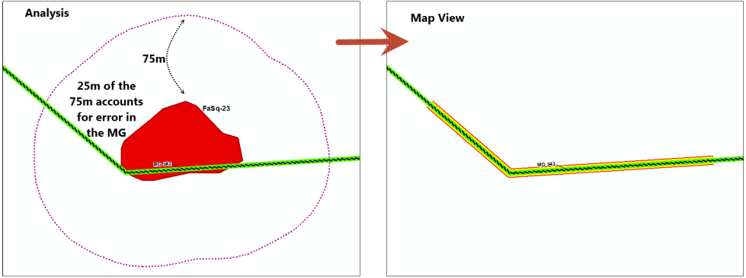
- Required datasets
  - Rehab Line in GDB (wildfireBC_Rehab\wildfireBC_Rehab_Line)
Selection: FLType IN ( '10', '20', '9', '28', '37', '11', '30', '21', '16', '24', '22', '32', '27', '34', '35')
  - WHSE_ARCHAEOLOGY.RAAD_TFM_SITE
Query (updated): REGISTRATIONSTATUS IN ('Decision Pending', 'Federal Jurisdiction', 'Legacy', 'Recorded/Unprotected', 'Registered', 'Registry Candidate')
- For the RAAD data – Select by location for any Arch (RAAD) data within 75m of the selected rehabs lines above.
If no Arch (RAAD) data is selected, you are finished with this section until more Guards are added to the database. If there is Arch (RAAD) data within 75m continue onto the next step.
- Since this process needs to be repeated when there are new guards added to the Rehab database, its best to create a new feature of Arch (RAAD) Data with a 75m Buffer within 1km of the fire perimeter. You can use a select by location based on the fire perimeter and then export into the GDB. If you get an error, check to make sure “Background Processing” is unchecked.
- The number of Rehab lines that fall within 75m of an Arch Site is fairly low. It’s best to do a “Select by Location” and go to each of the Rehab line and
  - Break the Rehab line
  - Classify the line segment (use the provided Domain) to “High Priority - within 50m of and Arch Site”.
  - Update the line length [Metres].

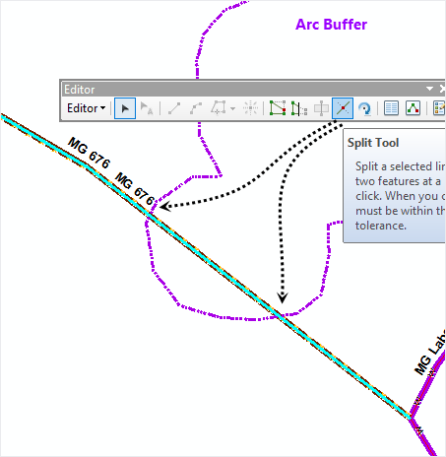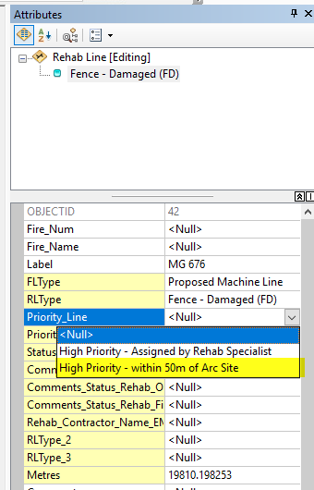

- When new Guard/Rehab Line is added to the database, remember to check for new lines that should be updated with high priority attributed to them. Send out updated datasets if required.

Step 3 - Importing Field data

Most Rehab data is collected in Avenza and comes in the form of a KML. A few tools have been provided to the Rehab Specialist to aid in data collection and to remove some of the uncertainty. Attributes can be lost when using the ArcGIS KML to Layer. XTools Pro has a better tool, Import Data From KML. If the latter tool crashes use the KML to Layer in junction with the KML open in Google Earth Pro to populate the attributes. The KML should always be open in Google earth as a way to QC and to make sure you covered every point and line. The photos can be imported using windows explorer by changing the file extension. More details in a later section.

Before making lots of changes, it always best to back up the GDB.

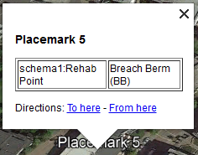
Receiving a KML – Import using Xtools Pro

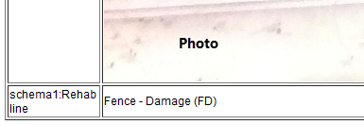
There are two options when receiving a KML. Open then KML in Google Earth. The KML could be built in two different ways. If a schema was used in Avenza then there will be attributes associated with each point. If you use the KML to Layer in ArcGIS to import this KML the attributes will be lost. To find out if there are attributes, once open in Google Earth click on the point and see if there are attributes (See pic). If a style file was used when collecting the data in Avenza not all of the point styles will show up in Google Earth (they will show up in ArcGIS). If there is a photo attached, you will have to scroll down to see the attributes.

No Schema
There might just be a point or line with an acronym as the description. These acronyms should correspond with the Rehab Treatment options.

i.e. A point with a RD is a Restore Draw, a DW is Decked Wood. Same process with the Rehab Lines.

A line with NA is a ‘No Treatment’. A line with PB is Pull Back. Some rehab lines might need to be split into smaller segments. Issues arise when the line segment is so short that it will not show up in a 5K map. Consider placing a point with a label showing the length of treatment in ADDITION to the line treatment.

Bringing Data into the Rehab database

QC the KML Data
The KML Schema is set up to collect up to three Rehab treatments for each the point and the line. Unlike in GIS, In Avenza the attribute and the style/symbol are chosen separately when a point or line is collected in the field.
Mistakes to look for:
- If there is only one attribute and it does not match the style/symbol then go with the Rehab Treatment (attribute) AND add the style as a second rehab treatment point. Then check with the Rehab specialist who collected the data.
- If there is NO attribute but there is a style chosen, use the style for the Rehab Treatment point.

Note: As mentioned previously, the styles from created in data collection in Avenza KML may not show up in Google Earth. Using Google Earth is the best way to look at attributes. Use ArcGIS to look at symbol/style.

When working with KMLs, its best to enter the data point by point and line by line and to have the KML open in Google earth.

POINTS
Each Point feature in the Rehab Database can ONLY contain one Rehab Treatment. If the KML schema is used, it can hold up to three Rehab Treatments.
Items of Note:
- Many contractors will only receive a map and most do not have GIS support. If two points fall in the same location with different treatments its best to add labels to make sure these points are not missed. Many contractors will only receive a map and most do not have GIS support to work with databases.
Note: We are working on different methods of dispersing points to prevent this issue.
- Rehab treatment set to ‘Unique Point’ require a label. Check KML in Google earth, if still no label then check with the Rehab Specialist for one, or if the point should be removed from database. There is a chance that this was a mistake or only import to the person collecting it has should not be entered into the Rehab Database. If clarity is not provided, consider making this point Rehab Treatment as ‘Unassigned’.
- Rehab treatment set to ‘Other Rehab Treatment Type’ also requires a label. Check KML in Google earth, if still no label, then check with the Rehab Specialist for one, or if the point should be removed from database.
- Only check a point as “Field Verified” if the Rehab Specialist has addressed that specific point.

LINES
Unlike points, each Line feature in the Rehab Database can contain THREE Rehab Treatments. If the KML schema is used, it can also hold up to three Rehab Treatments.

Lines should be digitized from KML (SHP) vs copied over to Rehab Database. The lengths of the lines can play an important role when planning and budgeting. Lines that are longer because the persons track zigged and zagged, went circles, folder back over on itself or small tangents are not helpful. Unlike points, Rehab lines can hold up to three rehab Treatments in the Rehab GDB. Never should there be a line on top of a line unless it’s an intersection.
Items of Note:
- DO NOT Place line on top of an existing line. Remember one line contains BOTH Incident and up to three Rehab Treatments.
- If different sections of ONE line require different Rehab treatments use the Split Tool (on Editor Toolbar) to split the line and assign different Rehab Treatments. If a fourth Rehab treatment is needed, add an additional field [RLType_4] and link it to the associated geodatabase domain. E-mail Kyle Miller [Kyle.Miller@gov.bc.ca] or Steve Richards [Steve.Richards@gov.bc.ca] so we can consider adding a fourth to the template Rehab GDB or you aquire any assistance adding a fourth to the dataset.
- Duplicate Lines – When a track is collected and it already exists in the database, choose the line/track you think is most accurate.
  - The first one might have been drawn in Google Earth and the latest track might better represent the line in the field. In this case you would ‘Retire’ the existing one and digitize the latest one. Update the latest rehab line with a rehab treatment (or leave it as ‘Unassigned’) and change the [Status] to “Rehab - Field Verified”.
  - If you decide to go with the line already in the database, update the [Status] to “Rehab - Field Verified” and add any rehab treatment if one was provided.
In both options, populate the [Comments_Status_Rehab_Field_Verified] with the YYYYMMDD and name of who field verified the line.
- Duplicate tracks - When the KML tracks are collected they, could have a track running in both directions.
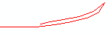
i.e. You only want one in the database. Digitize from one end to the other. Remember to remove any extra loops and tangents. The [Status] should be set to “Rehab - Field Verified”. It does not matter if this track was or was not in the database.
- Roads – When entering a new line, check to see if Guards are being entered over FSR or other types of roads. Many Modified roads or just heavily used roads get entered as Guards, this also messes up the planning and budgeting. This could be tough because not all of the roads in the database exist and it could actually be a guard (but not as likely as a Modified Road).
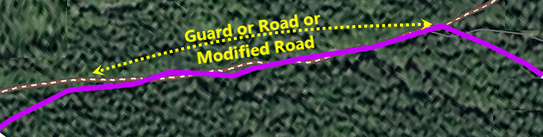
- Track data – You receive part of a line that already exists in your database. Use the Split Tool (on Editor Toolbar) to split the line in the database and treat the new line track as you would a duplicate Line (see #1 above). Only update the status for the track received. In the example below, the orange line was the track received that was NA (No Treatment).
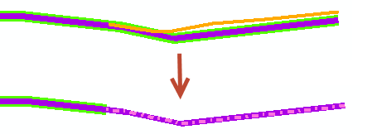

Cleaning up the Data

Duplicate Lines
When data gets copied over from Incident there is a chance the data was rushed and could have duplicate lines, or a Rehab project could have been inherited by someone who did not create a clean dataset.
On a smaller fire, it’s easy to look for duplicate lines or line segments,
- open the table and look for lines with the exact line lengths and secondly
- zoom to each line in the dataset and select them on the screen to make sure there is only one line.
On a larger fire, this process would be more time consuming. Create a feature that tells you what areas need attention.
- Export Rehab_Line feature class into a temporary database.
- Densify the line (try 30m distance) – this adds vertices every 30m
- Feature Vertices To Points – converts each vertices in the line feature into a point
- Buffer the feature you just created above (try 30m) – buffers each point
- Do a spatial join with the Buffer (as Target) and the point file (join), JOIN_ONE_TO_ONE and keep all target features – this will create a density of the # of points found in each poly.
- With the result Poly feature, display using Graduated colours based on [Join_Count] and this will help you target areas with messy Zig-Zag lines and overlapping lines.
It might help when in the symbology to go under advanced – select Symbol Levels – check the box and place the ones with the highest count at the top.
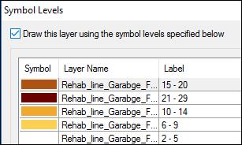
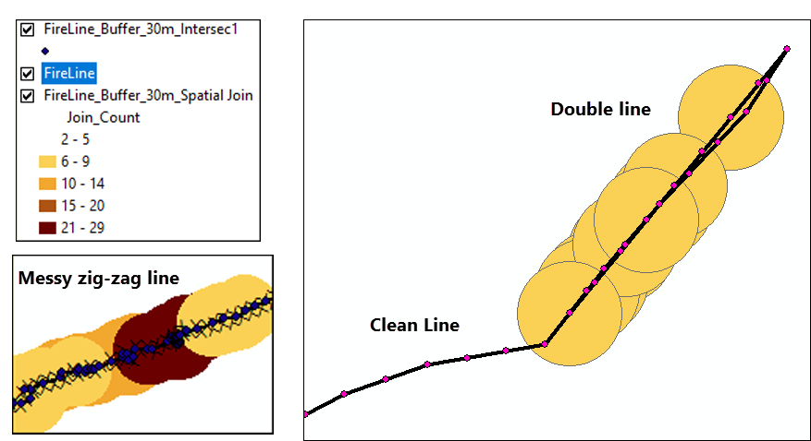
Action: Digitize a less zig-zag line and remove any duplicate lines. Or run a smooth Line for just the problem lines.

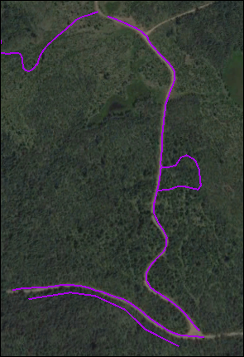
A few examples of data errors.
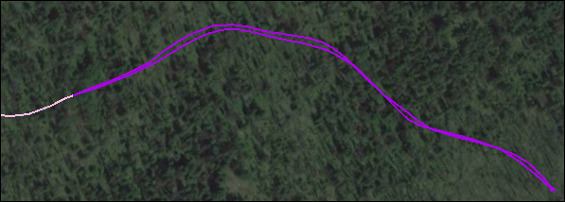

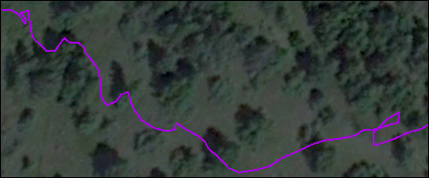

OPTION 2
Once you find the problem lines, you can run a smooth Line tool. This is an example of 10m to 50m Smoothing Tolerance. You would still need to remove the loop where the person walked in circles. DO NOT USE THIS ON THE ENTIRE DATABASE. The more accurate the line lengths are, the easier it will be to plan for Rehab time and costs. Smoothing all lines will possibly underestimate line lengths.
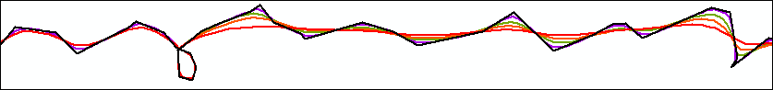

Guards that could be Modified Roads or just Heavely used Roads
If there is a track that is classified as a Guard that falls on an existing road it may need to be classified as a Modified Road or in some cases just as a heavily used road. When it comes to planning for Rehab, dealing with contractors, it’s a big issue when used roads are classified as Modified Roads, and especially if Modified Roads are classified as Guards. Keep an eye on the imagery and the roads features in the database. Ask questions if you receive a guard that falls on what appears to be a road.

Bringing in the field data one feature at a time should remove this type of error. On small fires, it is easier to do a visual analysis to look for these records. A process that helps for a larger fire would be to buffer all of the roads within appx. 500m of the fire perimeter and buffer the roads by 25m. Append these features into one, intersect this buffer with the Rehab Guards and then target these areas looking at the imagery to see if the roads exist. Check with rehab specialist to see what minimum length of line is important to target. There could be a very large number of small segments that go near or on existing roads for short distances. This amount of detail may not be necessary and can be time consuming. (i.e. >100-150m segments might be a good target number). After looking at the imagery, adjust the guards that follow an existing road to [FLTYPE] = Modified road. For questionable areas where we do not see a road in the imagery, send Rehab lines and buffer the guards that questionable as KMLs to the Rehab Specialist so they can look into these areas.

Note: Error? – If you see an error like the one below, try dragging the feature out of the Layer tree (see second pic)
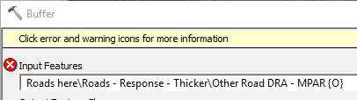
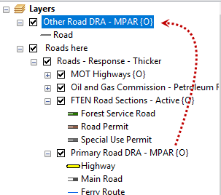

Status
When a [Status] changes, the date and the name of the Rehab Specialist should be documented in the Attributes. In the case of “Obligations Transferred”, enter the name of who took on the responsibility. Also, include the name of the Rehab Specialist who asked for this request.
When changing a [Status], always us Domain drop downs. Do not use the Field Calculator or type in the Status manually. See Data Migration section for how to do this.

Update the [Comments…] attribute to reflect any change.
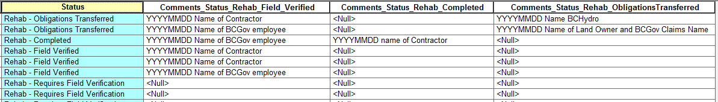

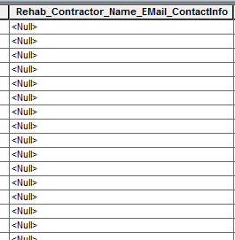
New: Ask the Rehab Specialist for the contact info (Name, E-mail and Phone) for the Contractor who is undertaking the Rehab work and enter this into [Rehab_Contractor_Name_EMail_ContactInfo] field.

KML has Schema
Schema means that the person who collected the data used a pick list and styles provided in Avenza. This info would be lost if just imported as KML to Feature in ArcGIS. Open in Google Earth to see if the KML has schema (Attribute info).

There are two Steps when importing this KML.
Step 1 – Import Points and Lines with Attributes
Step 2 – Import Imagery (into a folder)

Step 1 – Import Points and Lines with Attributes
This step will not save the imagery. It will create a Layerfile and one or more SHP files.
- Save KMZ in the project folder.
……. <Fire Number>\Data\Incoming\Rehab\YYYYMMDD_+ Name of data collector
- In ArcGIS turn, on XTools Pro
- Open XTools Pro Tool Bar
- Using the drop down on the tool bar, select “Import Data from KML”
- Make sure to
- Keep Additional Attributes
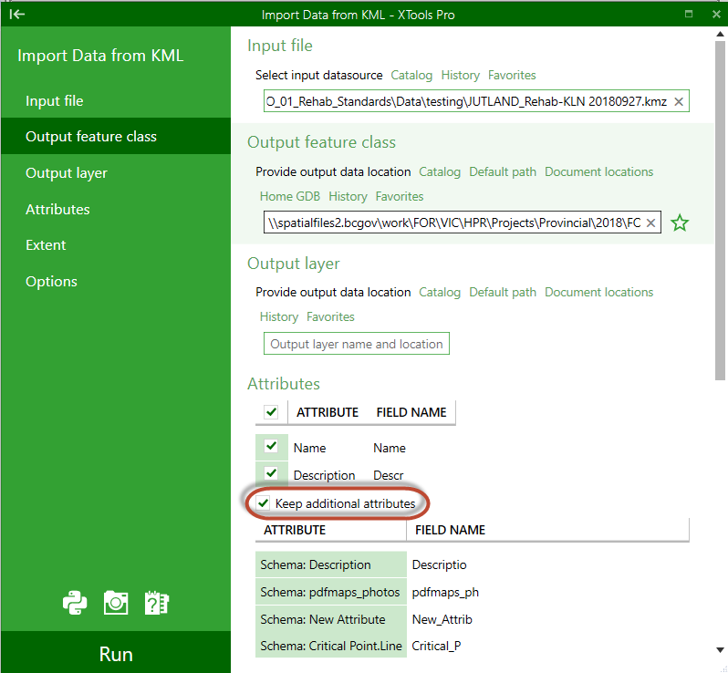

Step 2 – Import Imagery
- Make a copy of the KMZ.
- Change the KML to a ZIP extension. (Do NOT R-click and compress the file)
- R-click and extract data.
- Inside the new folder there will be a folder called images.
- Go out one folder and Rename the folder to have _photo at the end
No further action for this process at this point.

FINAL PRODUCT should look something like this. Photos can be found in the first folder.
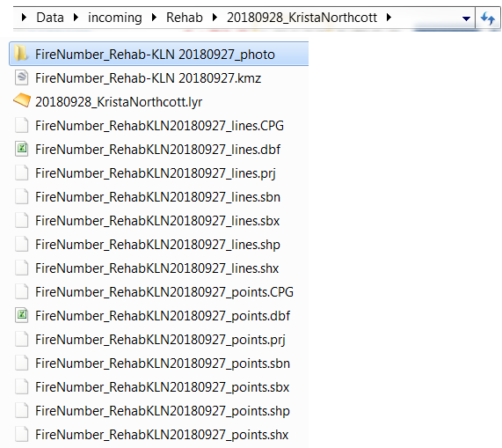

Photo Collection in Avenza
BC Government Employees should refer to the SOG Notebooks and Photos.
It is important that adequate georeferenced photos are taken by the Rehab Specialist, particularly for high-risk areas. A naming convention that ensures that photos can be spatially matched with the corresponding feature in the rehab plan must be used.

Naming Convention:
Initial Photo File Name | Final Photo File Name Example
Incident # / Unique identifier / YYYMMDD / Initials of person who took photo | K20637 002 20180707 KN

Step 4 - GIS Products
Many different map products and tables can potentially be produced, and a few examples are provided below:
- Field Maps (to be used in Avenza 5K scale is best) – This is the default product.
- Plotter Maps (Poster size) – 10k scale maps
- High Priority Maps (data dependant scale)
- Overview Maps (used for navigation or overview meetings)
- PID Maps (Private Parcels) – DDP for each PID of interest.

MAPs

Rehab maps with a scale Preferred 1:5k – recommended for field data collection
Rehab maps for plotting, have a preferred scale of <1:10K. – recommended for meetings
Overview maps used for navigation or overview planning can be >1:10K

Map Template Scale VS Extent on the ground | 1:5K |  | 1:10K |  | 1:20K
Map Template Scale VS Extent on the ground | Extent of coverage of Fire Perimeter and Rehab Treatment
Map Template Scale VS Extent on the ground | Width (km) | height (km) | width (km) | height (km) | width (km) | height (km)
REHAB_Template_11x17L | 1.8 | 1.3 | 3.6 | 2.5 | 7.2 | 5
REHAB_Template_11x17P | 1 | 2 | 1.9 | 3.9 | 3.7 | 7.7
REHAB_Template_22x34P | 3.7 | 2.6 | 7.5 | 5.2 | 14.9 | 10.5
REHAB_Template_24x36L | 4 | 3 | 5.7 | 8.1 | 15.9 | 11.5
REHAB_Template_36x48L | 5.3 | 4.3 | 10.6 | 8.8 | 21.4 | 17.8
REHAB_AvenzaTemplate_100x100L | 11.8 | 12.4 | 23 | 24

i.e. If fire and associated data has an extent of 3 x3 km, then the smallest map template for field data collection would be REHAB_Template_24x36.MXD. A REHAB_Template_11x17L would work for meetings and overview maps.

Maps will include standard basemap features and other features that have special interest to Rehab Specialists. Standard basemap features include: Roads, Hydrology, Critical Infrastructure, First Nations, Land Ownership, Parks, Tenures, Client Agreement, Archaeological Sites, Archaeological potential High and Moderate, terrain stability, Safety Features and Range Improvement fences and infrastructure. See picture below for list of current features.
Warning! Imagery Maps made with transparencies might not allow the Imagery to show up in Avenza even though it does show up in the PDF. Turn on Toolbar Detect Complex Output - Detect Raster to see if you have any Rasterization.

Map – QC
Naming convention should be the same as in Incident. Feel free to add the scale to the PDF name.
i.e. <Fire Number> REHAB Avenza 5k 100x100 YYYMMDD.PDF
Before exporting check:
- Open the Tool Bar for Detect Complex Output and click on the Detect Raster. There should be no transparent features in the maps. Any transparent features might not allow any layers below to appear in Avenza even though they appear in the PDF. If features show up on the list but have 0% transparency, the best option in to bring in the feature from scratch and give it the same, style, query and name.
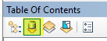
- In the Table of Contents – Click on List by Source
Scroll to the bottom to make sure there are no !
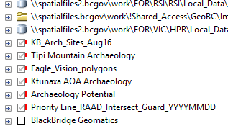

Map – Feature Order
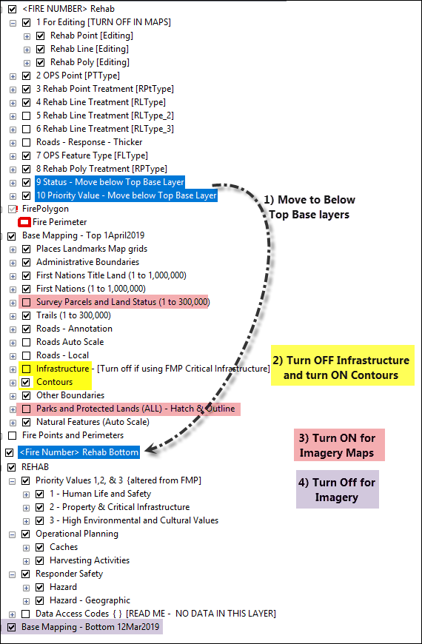
Turn off the infrastructure and turn on the Contours. When exporting Imagery Turn off the Bottom Layer and turn on the Survey Parcels and the Parks.

Map – exporting Imagery
Make sure the Survey Parcels and Land Status and Parks and Protected Areas are already turned on. Just turn off the Base Bottom and the REHAB Bottom and export with Imagery. You will have to drop the DPI and the Quality until imagery shows up in the PDF.
NOTE: The imagery will show up in the PDF before it will show up on your screen.
If Imagery map is cluttered with data and the Imagery is not easily seen, offer a SECOND Imagery map with reduced features. i.e Rehab data, Roads and Survey Parcels and Land Status.

Map – Extent
Unlike an incident Map, the fire is likely no longer growing so the extent of the map can be set to just go beyond the fire perimeter. These maps will typically be used for field data collection and should be of a 1:10K (if possible a 1:5k scale).

Map Sets
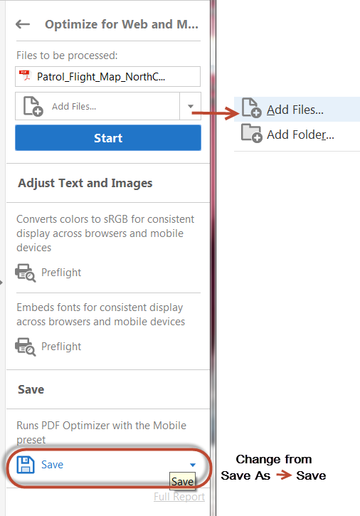
Produce two map sets, one with and one without imagery. Since the Survey Parcels and Parks are already turned on, just add the imagery, the date of the imagery and turn off the Base Mapping Bottom.
Look In Imagery Section for help with setting up Imagery. Black Bridge imagery should be the first choice and if the imagery is poor use Ortholoader the second. Black Bridge has the latest imagery date making it desirable.

Note: Ortholoader might be needed for some of the PID maps.

Shrink PDFs using Adobe
Two Options
Optimize PDF or Reduce Size PDF

PDF Optimizer – best option
To Optimize one PDF:
File – Save as Other – Optimized PDF – OK
To shrink multiple PDFs:
Go to Tools – Action Wizard - Optimize for Web Mobile
Use the drop down Add Files and change Save As to Save (see Pic below).
Note: When you add the files also include the one you have open.

Reduce Size PDF
To shrink one PDF:
Open PDF - File – Save as Other – Reduce Size PDF - OK.
To shrink multiple PDFs:
Open PDF or Adobe Acrobat Pro DC is - File – Save as Other – Reduce Size PDF – Apply to Multiple Files – Add Files…
Note: When you add the files also include the one you have open.

Map Grid
Some fires cover a very large area and may need more than one map. Setting up a map grid at the beginning is important so that there is consistent map extent and naming for each area. This also helps with field data collection and file organization. In this example, two sets of Grids were needed. One 10K and another at 5K.
The 10K map Grid was used for plotter posters and the 5K set was used for Avenza App.
The map below provides the Elephant Hill Fire as an example. At approximately 192,000 hectares in size, it required 39 maps at a scale of 1:10,000.

Field Maps (Avenza)
Rehab specialist may request a set of very large electronic maps with lots of detail with a scale of 5K (1:5000). These maps can be brought into Avenza for data collection in the field. For larger fires, several maps may be needed to cover the entire area. Imagery can be an option and if high resolution imagery is available, it can be added. These small-scale maps are not designed to be plotted/printed.

VIP: Always shrink the maps. Otherwise, they will be too large for field use. Adobe Acrobat Pro DC is required to shrink PDFs.

Plotter Maps (Poster size)
Maps at 10K (1:10,000 Scale), approximately 36x48 inches, can be plotted for planning and field use. If high resolution imagery is available, it can be added. Although, it may make the maps less readable if there is a lot of other detail on the maps. The scale can be increased to produce fewer maps with less detail, or decreased to produce more maps with more detail, at the discretion of the Rehab Specialist.

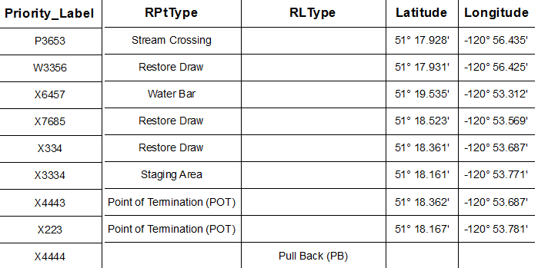
High Priority Maps
High priority features are identified by the Rehab Specialist. This type of map will include a table that provides coordinates and unique labels for each point/line/polygon on the map. Map size and scale can vary. See table above that will be added to these maps.

Overview Maps (Poster size)
Overview maps for large fires are typically at a map scale of 50K (1:50,000) and have limitations on how much detail can be shown. This scale does not allow enough detail to provide PIDs or any labels for rehab treatments.

PID Maps (Private Parcels)
These are 11x17 maps that are created using DDP. With some data prep these maps will contain:
- PID #
- Length of Line on that parcel
- Title info for that parcel
- Rehab data
- Other features of interest listed under MAPs

Special features
- Table in the top left - Lengths of [RLType] and [FLType] for each individual PID.
- Text box top right - Length of total line across the PID.
- Automated filling in of the fire name and Number (from the FirePolygon)
- Bottom Right – Overview of surrounding area.

Tip for Graphic Table Element: To get the lengths to round to the nearest metre.
Table Properties - Data Source - Select Feature - Field Mapping - Select Field - Expression - Round[(Length_m),1)
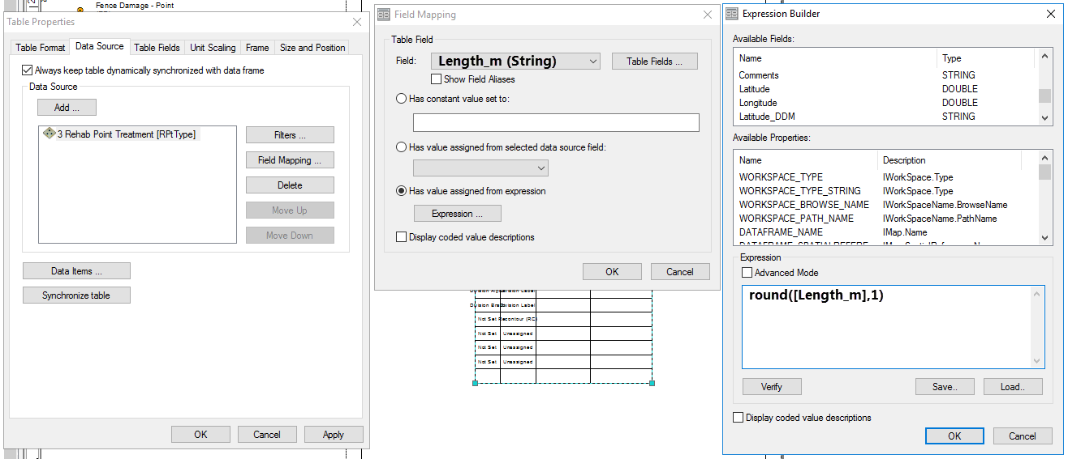

Exporting Data

Exporting to Shapefile
Additional steps are required to export the geodatabase feature classes to SHP, due to the geodatabase domains. A simple export will result in the coded domain values being exported (numbers) and not the descriptions, which can cause issues to those not familiar with the geodatabase schema. Always provide a layerfile with the outgoing data and make sure to set the [Status] correctly.

One Option:
Step 1
- Feature Class to Feature Class
This will not populate the attributes that have domains with the descriptions in the [PTType] or [RLType]. It will create new attributes that contain the Domain Descriptions.
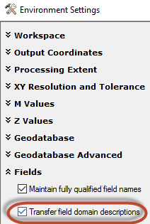
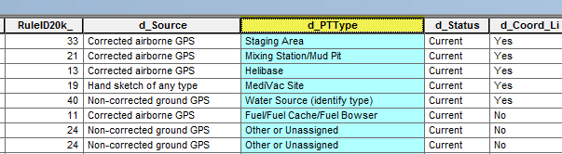
- Output Location:
\\spatialfiles.bcgov\work\!Shared_Access\Provincial_Wildfire_Rehab\FireSeasonWork\<YYYY>\<Fire Centre> \<FireZone>\<FireNumber>\Outputs\DataForDelivery\Rehab\
Create a new folder.
YYYYMMDD_<Description>_<ClinetName>\
- Output Feature Class:
In the Output Feature Class name it with a .SHP or leave blank
YYYYMMDD_Rehab_<Description>.SHP
- Environments… - Fields - Check the box to Transfer field to Domain Descriptions.

Step 2
Copy symbology from the Rehab Line or Rehab Point and paste on your new SHP file.
R-click on the Rehab line or point – Copy Properties – Copy Symbology. Then, R-Click on the SHP you did created – Paste properties – OK
Note: If these options are greyed out you need to turn on the XTools Pro extension.

Step 4
Open the attribute table and make sure there are new attributes with the domains populated as text and not numbers. Delete any attributes that are not necessary.

Step 5
Save as a Layer file in the folder created in Step 1. Zip up folder if necessary. Remember to rename with ZZZ if being sent via E-mail.
Note: If this is data that requires password protection use QR Password 7 Zip Files.docx. The external client will also have to download software to extract the data. If there is any Arch or Arch Potential data them a password is required.

Exporting GDB
Step 1
Create a new folder in
\\spatialfiles.bcgov\work\!Shared_Access\Provincial_Wildfire_Rehab\FireSeasonWork\<YYYY>\<Fire Centre> \<Fire Zone>\<FireNumber>\Outputs\DataForDelivery\Rehab\ YYYYMMDD_<Description>_<ClinetName>
Step 2
Copy GDB into folder. Delete all features in the database.

Step 3
Select only the data requested by the client. Export that data into the database. Bring the features you just created into the MXD.
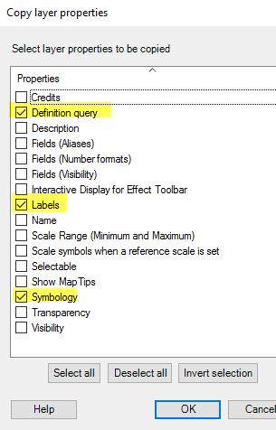
Step 4
Select the layer pointing to the original GDB and contains the Rehab symbology (not the feature class you just created), R-click – Copy Properties – Copy Properties. Select: Definition query, Labels, Symbology.
Note: If these options are greyed out you need to turn on the XTools Pro extension.

Step 5
R-Click on the feature class you created – Paste properties – OK

Step 6
Save as a Layer file in the folder created in Step 1. Zip up folder if necessary. Remember to rename with .ZZZ if being sent via E-mail.
Note: If this is data that requires password protection use QR Password 7 Zip Files.docx

Naming Convention

MXD Naming Convention
<FireNumber>_<Theme>_<PageSize>_<version>. MXD
Example: C20145_Rehab_22x36L.mxd or C20145_Rehab_22x36L_V2.mxd

Note: Do not put dates on MXD’s because most data is live linked and will not correspond to the date of the mxd.

PDF Map Naming Convention
Take note of the addition of the scale to the PDF name. It will help the user know if it can be used for data collection or if it’s an overview map for a report.

YY <FireNumber> MAP <Theme> <Scale> <PageSize> <YYYYMMDD>. PDF
Example: 19 C20145 MAP Rehab 5k 22x36L 20190716.pdf

IMAGERY – if the PDF contains imagery add IMG to the file name.
Example: 19 C20145 MAP Rehab 5K IMG 22x34P 20190716.pdf

Optional: if multiple versions of a particular incident are being created (perimeter updates/progression, include <Version > or the time at the end of the filename.

Example: 19 C20145 MAP Rehab 5k 22x36L 20190716 v2.pdf
Or
19 C20145 MAP Rehab 5k 22x36L 20190716 1045.pdf

Note: Records management (TRIM) has specified that no underscores can be used in the naming conventions. Please use spaces instead of underscores.

Step 5 -Documention
Update daily the Rehab document to improve project turnover and to make it easier for others to reproduce special tasks that you have been assigned. You can find this document in the Documents folder in the Fire Project Folder.
<FireNumber>/Documents/ FIRENUMBER_GISS_Turnover_DailyLog.docx

Field Data Collection

The GIS Specialists are working on providing other options for Field Data collections. Currently, field crews are using Avenza.

Avenza

Currently, field data is collected using Avenza. Avenza allows a Rehab Specialist to:
- Import any PDF map, including those made by the GIS Specialist.
  - A large scale map (eg. 1:5,000) is recommended for field work.
  - A small scale map (eg. 1:30,000) can be useful as an overview and for navigation.
  - Internet or cell coverage is required to import maps into Avenza and maps should be loaded before heading to the field. Once loaded, maps can be used without internet or cell coverage.
  - User location shows up as a blue dot on the map.
  - If importing KML Schema or style to use in Avenza would also need to be done within cell coverage or wifi.
- Create a KML to collect field data which may include:
  - Drop Points (using current location or marked location) with assigned attributes, descriptive text, and a photo.
  - Lines (using the measure tool or by tracking your movements) with assigned attributes, descriptive text, and a photo.
- Utilize schema to enter data rather than manually entering the information.
  - When a point or line is created a drop down list is available to select the Rehab Treatment Type. This will reduce errors and speed up data collection.
  - The attached KML can be imported into Avenza and used for the collection of rehab treatment points and lines:
Data Collection Schema
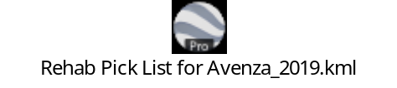
Data Collection Styles/Icons/Symbology (Export from E-mail into Avenza)
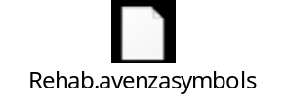
Information regarding how to import and use KML Schema can be found in the reference Guides for Avenza.
- Export the data collected via email as a KML to the GIS Specialist for map production/updating. (NB: Internet is required).
- Export the data collected via e-mail or to Google Earth if immediate use is required (NB: Internet is required). Opening the collected data in Google Earth is useful for quality checking and cleaning up the data before submission.

Importing Photos into Arcgis
Make a copy of the received KML that contains pictures and rename the file *.ZIP. Extract and there should be an imagery folder.

Avenza User Guide
Instructions for Avenza and other tools can be found here:
  - Avenza Website
iOS
http://help.avenzamaps.com/customer/en/portal/topics/950368-avenza-maps-for-ios/articles
Android
http://help.avenzamaps.com/customer/en/portal/topics/951155-avenza-maps-for-android/articles

  - BCWS Server
    - QR Avenza.docx or QR_Google_Earth_KML.docx
\\spatialfiles2.bcgov\work\FOR\VIC\HPR\Library\!Processes_Procedures\ReferenceGuides\QRs

Avenza Maps Pro License
BC Wildfire has a Corporate License that allows for full functionality of Avenza. Avenza is best used on an iPad or Android with an operating system of 6.0 or newer, as earlier versions may have a minor shift in the data when exported. Avenza Maps has two license options: A free version called Avenza Maps, that has limited functionality and to be used for non-commercial, and a second version called Avenza Maps Pro. Contractors will be responsible to purchase their own License through Avenza Maps Pro for the cost of $99. BC Wildfire has a corporate license for the Pro version.
NOTE: This license is ONLY for the use of BC Government employees.
To obtain the License Key code, check the current year document in the link here. Otherwise, contact NRS Maps at NRS.MAPS@gov.bc.ca.
Once the App is installed, go into the setting and entre the License Key to gain full functionally of the App.
Other details will be required to aid in develop of cost sharing agreement and to limit License users to BC Gov employees.
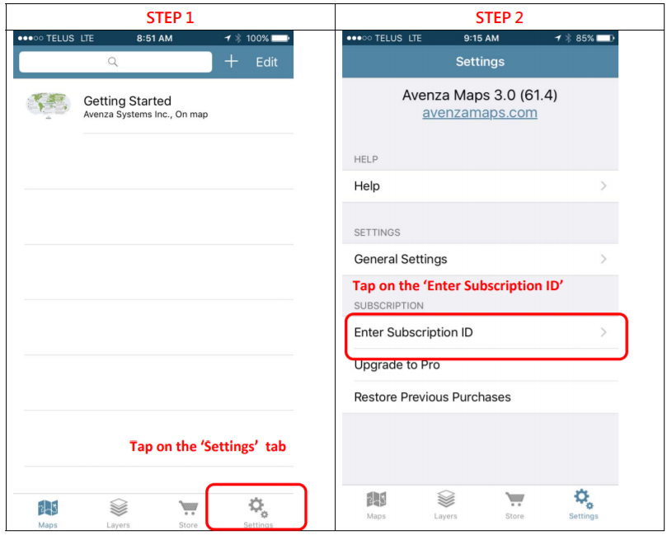

Field Data Submissions
Data Submission Requirements
Data should be submitted in KML format. All identified points and lines should be assigned actions that are planned to be undertaken in the field (or “no treatment). Fireguards should be captured in one track from start to end when the combination of treatments prescribed is the same along the entire length of the fireguard. Fireguards that have different treatment combinations over their length should be split into segments that reflect each unique treatment combination. Do not include additional data related to travel from one fireguard to another. Do not classify modified roads or heavily used roads as fireguards (even if they served this function during fire control operations). Fireguards with more than one type of treatment should have the spatial data collected only once, and then assigned the specific treatments as prescribed. If no actions are prescribed on a section of fireguard, the section should be identified as “no treatment” and a comment should be included that specifies the associated rationale. When adding a rehab point, use the KML provided or the options from the Rehab Points, and/or Rehab Lines treatment options. If adding missing incident data, use the correct Incident Line [FLType] classification.

Naming Convention:
The KML should be named with the date, followed by the action planned, the name of the person or client collecting the data, followed by a unique identifier.
For example: YYYYMMDD_<Rehab Action>_JaneDoe_track1.KML. Multiple KML’s can also be grouped into one.
Example below was taken from Google Earth.
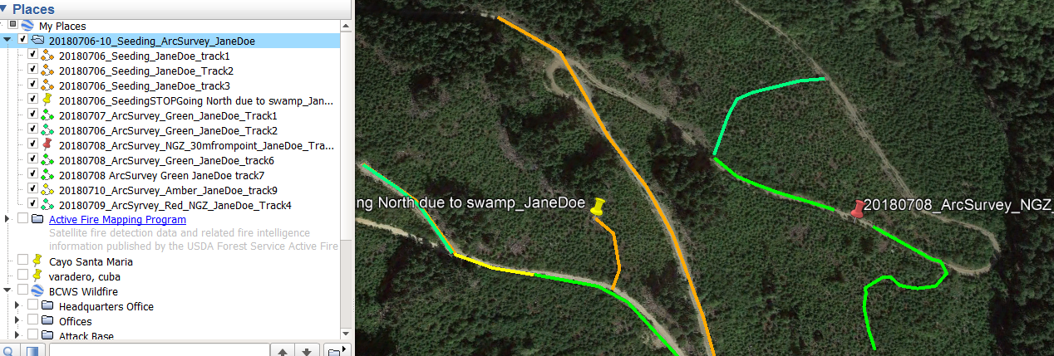

In Avenza during the export you can rename the KML to follow the naming convention.
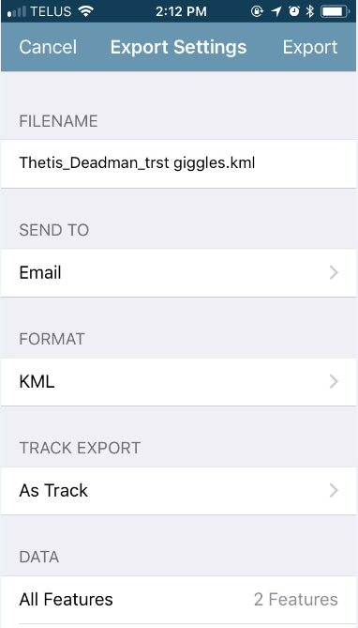
A qualified person could also submit a Shapefile or Geodatabase provided it provides the incident data and planned rehab actions, the date it was collected, and identifies the person collecting the data.

Wildfire SDE
This is a service only for BCGov employees
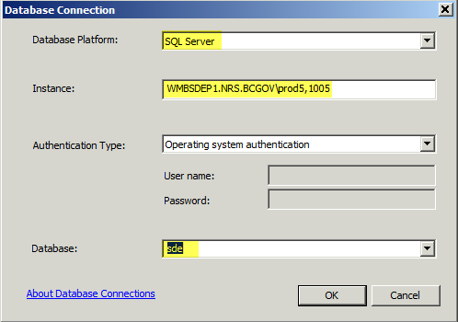
ArcGIS 10.3 and ArcGIS 10.6.1
- In ArcCataog add >Database Connection
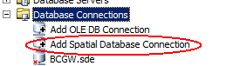

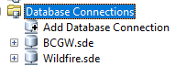
Database Platform: SQL Server
Instance: WMBSDEP1.NRS.BCGOV\prod5,1005
Authentication Type: Operating system authentication
Database: sde

- When the connection has been set up rename it to Wildfire.sde

Imagery

This is a service only for BCGov employees.

There are two Imagery sources that can be used.

    - BC Gov. purchased imagery (limited coverage)
\\Imagefiles.bcgov\imagery\urgent_status_imagery
    - PlanetLabs (was known as BlackBridge Imagery) or
    - Ortholoader

BC Gov Imagery has the highest resolution and usually captured post fire making it the best option, but coverage is very limited. As a second option use Plant Labs Imagery (was called Black Bridge) it is usually more recent than the Ortholoader imagery. If Plant Labs Imagery is of poor quality, then use Ortholoader as a third option. Remember to provide Imagery source and dates in the map.

Action: In the map, add the data of the imagery under the Data Sources and Notes that’s just above the scale bar.

BC GovermEnt Imagery

The BC Gov has purchased a few selected fires to acquire high resolution imagery. Check this location for fires that have imagery.
\\Imagefiles.bcgov\imagery\urgent_status_imagery

PlanET Labs Imagery (formally known as Black Bridge)

Please make a request to BCWS Geospatial Services FLNR:EX BCWILDFIREGEO@gov.bc.ca for WMS server, username and password.

Imagery will not export?
When exporting poster size you will want to drop the resolution to 280 DPI and drop the quality by one notch. If that doesn’t work keep dropping the DPI until the imagery exports.

Action: Use Shapefile in the layerfile to add the imagery date to the map.

Ortholoader

Several tools have been built to support fire incident mapping and can be found in the Toolbox: WildfireBC_Tools.tbx

Located in: \\WildfireGeo.bcgov\Geomatics$\Resources\ToolsAndScripts\Tools
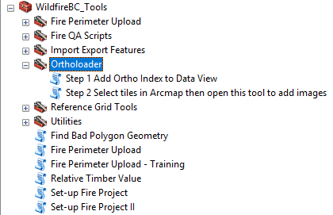

Ortholoader
These tools, developed by Graham MacGregor, assist the user in finding the most up-to-date ortho imagery for a specific location.

QR Guide for Ortholoader
W:\FOR\VIC\HPR\Library\!Processes_Procedures\ReferenceGuides\QRs\QR Adding Images_Ortholoader.docx

Data and Records Management
Take special note that some data is restricted and sensitive in nature. Do not place data or maps with archaeological data (Arch Potential or RAAD data/Archaeological Sites) on an external FTP site, unless the file is password protected and only if the contractors/licencee has the appropriate data sharing agreement in place. Do not release paper copies or data to unauthorized parties. Refer back to the FMP Catalogue for further details.

Updates to Data Model
If any issues are found with the data model or documentation, please contact Steve Richards (Steve.Richards@gov.bc.ca) or Kyle Miller (Kyle.Miller@gov.bc.ca).

References, Resources and Links
Wildfire Rehabilitation Hub – Contact Steve Richards for credentials (Steve.Richards@gov.bc.ca)
FMP Catalogue

APPENDIX

Broken Styles ? – Use the Tags on the right to try and make a new one.
The text after the word character will tell you what font was used to create the symbol.
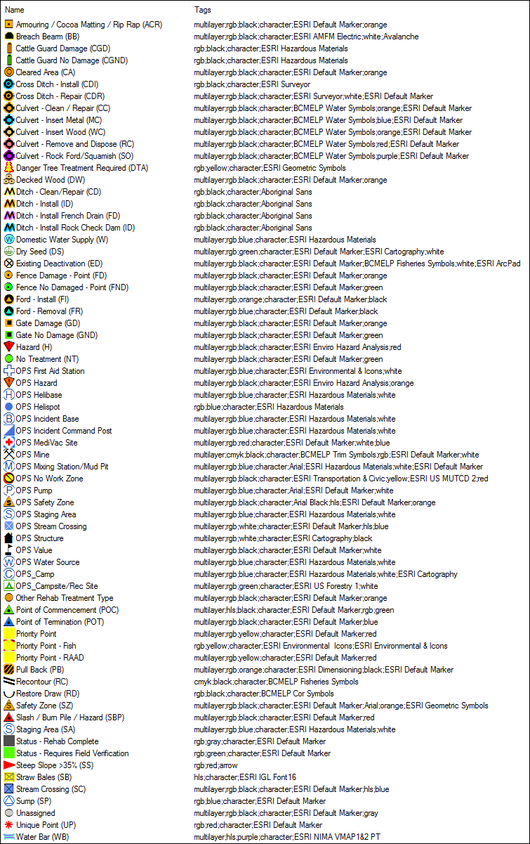

Document History

Version | Change Made | Effective Date
1.1 | Krista Northcott/Mike Black/Devona Hay | 20180604
1.2 | Krista Northcott/ | 20190415
1.3 | Steve Richards (Ministry of Forests) | 20220401

Approvals

